|  |
| --- |
| **User Manual** |
| **VisCanvas Data Visualization Software** |
| **Provided by:**  **Daniel Ortyn**  **Nicolas Espitia**  **Shane Vance**  **Brennan Barni** |

|  |
| --- |
| Data Visualization Group A  2-22-2018 |

Contents

Introduction 3

Getting Started 3

Saving/Reading VisCanvas Files 3

Main Window 4

Data Analysis/Manipulation Functions 4

Click and Drag 5

Sorting 6

Hypercube and Cluster Functions 6

Leveling Functions 7

Accessibility Functions 8

Secondary Properties Window 9

Class Tab 10

Set Tab 11

Dimension Tab 12

# Introduction

VisCanvas is a data visualization software, graphing data in a parallel coordinate format. Data is read from comma delimited text files with no spaces. The software includes a series of data manipulation and analysis functions, along with functions to improve accessibility to the software and data.

# Getting Started

The program has two windows in total that the user will be able to access the functions to: primary and secondary window. The primary window will hold the graphing panel where all n-dimensional data and graphing functions will be presented. The secondary window will have the user access all functions regarding the properties of data (i.e. data color, names, values, class assignment, etc.), and preferences. The secondary window functions will be separated by tabs, segregating functions by the data it affects (class, set, and dimensions).

Upon initial startup of VisCanvas, the user will be greeted with the main window. In order to begin graphing data points, the user should read in a comma delimited text file either through clicking the open file button on the top left of the screen or by pressing “CTRL+O”. From there, a dialog box will pop-up, where the user will be able to choose a file from any directory. Once a text file is chosen, the data will be brought back to the main window with the data visualized on the graphing window.

# Saving/Loading VisCanvas Files

Along with reading data from a typical comma delimited text file, VisCanvas is allows the user to save their progress with their visualization for later sessions of the software. Previously saved data may be read in again into the software, ready to continue analysis where left off.

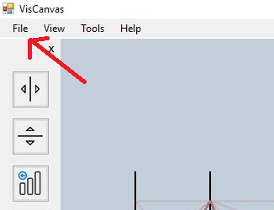

Figure 19 Save and open files through the File button at the top left of the main window

In order to save a file, one may do so by either accessing the “Save as” option in the “File” button at the top of the main window, or by simply pressing the hotkey “CTRL+S”. Choose the preferred directory the user will wish to save the text file to. Once finished, the software will leave the text file in the desired directory. WARNING: manipulating the file may lead to a corrupt file.

To open a saved file created from VisCanvas, simply access the “Open” option located in the “File” button at the top of the main window, or by pressing the hotkey “CTRL+O”. Navigate and choose the desired file to read in. The result will be the data with all previously made changes committed from the earlier session of the saved file.

# Main Window

The main window will have access to all data analysis and manipulation functions with limited properties manipulation functions on the left and right panels respectively. Once data is read into the software and presented to the user. The graphed data will have one n-dimensional coordinate highlighted in yellow. This highlighted coordinate is important as the sorting and hypercube functions are in respect to this coordinate. Highlighted coordinates can be changed by pressing either the “Up arrow” or “Down arrow”.

The left and right panels can be minimized in order to reduce clutter and view just the graph if the user want the option. To remove the left panel, press “CTRL+ALT+T”. To remove the right panel, press “CTRL+ALT+O”

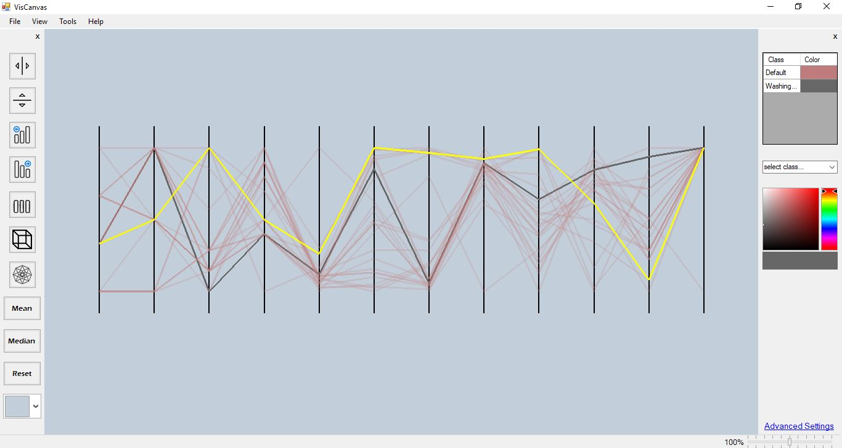

Figure 1 Main Window with read in data and a highlighted n-dimensional coordinate

## Data Analysis/Manipulation Functions

As mentioned, the main window holds all data analysis and manipulation functions held on the left panel. Many of these functions can also be performed either through accessing the “Tools” tab or hotkeys.

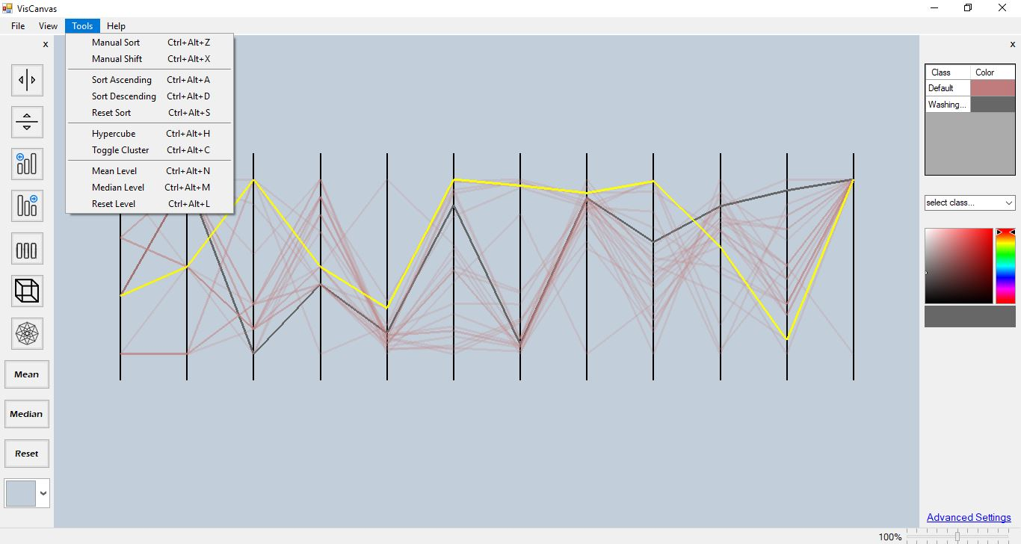

Figure 2 "Tools" Tab open to show the different functions and respective hotkeys in addition to the provided buttons on the left panel

These functions are as follows:

### Click and Drag

The VisCanvas software can perform both horizontal click and drag dimension swapping as well as vertical click and drag vertical dimension shifting.



Figure 3 Dimension swapping - Toggle this on in order to perform click and drag dimension swapping

In the case the user would like to manually move dimensions around the graph, they may do so by first clicking the button with two arrows pointing horizontally outwards away from each other, separated by a vertical line (clicking toggles on/off). Toggling the function may also be performed by pressing “CTRL+ALT+Z”. When the user toggles this button on, the may not manually sort any dimension they desire by simply clicking and holding on whatever dimension they want to move then dragging and dropping to whatever dimension location they would like to move that dimension to.



Figure 4 Vertical Dimension Shifting - Toggle this on in order to perform click and drag vertical dimension shifting

If there is the need to shift dimensions up or down, they may do so by first clicking the witht wo arrows pointing vertically outwards away from each other, separated by a horizontal line (clicking toggles on/ off). Toggling the function may also be performed by pressing “CTRL+ALT+X”. When the user toggles this button on, they may now move any dimension they desire by simply clicking and holding on whatever dimension they want to shift then dragging and dropping to whatever the desired height they would like that dimension to be graphed at.

### Sorting

VisCanvas sorting functions arranges the n-dimensions in either ascending or descending order, to the discretion of the user, and in respect of the highlighted n-dimensional coordinate. That said, not all n-dimensional coordinates will not all be sorted along said highlighted coordinate.



Figure 5 Sort in Ascending order - Sorts data from smallest to largest values in respect to the highlighted n-dimensional coordinate

Sorting the data in respect to the n-dimensional coordinate is performed by clicking the button with bars arranged from smallest to largest from left to right respectively. The function may also be performed by pressing “CTRL+ALT+A”.



Figure 6 Sort in Descending Order - Sorts data from largest to smallest values in respect to the highlighted n-dimensional coordinate

Sorting the data in respect to the n-dimensional coordinate is performed by licking the button with bars arranged from largest to smallest from left to right respectively. The function may also be performed by pressing “CTRL+ALT+D”.



Figure 7 Removing Sorts - Click button to revert changes to dimensional arrangements performed by ascending or descending sort functions

In the case the user wants to remove any sorting and return data to its original state before a sorting function, the user must press the button with the three bars of equal length. Doing so will reset the data to the state it was presented before any sorting functions occurred. The function may also be performed by pressing “CTRL+ALT+R”.

### Hypercube and Cluster Functions



Figure 8 Hypercube Analysis - Click button to perform hypercube analysis in respect to the highlighted n-dimensional coordinate

Hypercube analysis entails projecting a cluster of n-dimensional coordinates where each dimension is within the specified threshold distance of the correlating dimension of the highlighted n-dimensional coordinate. If at least one dimension does not rest within the specified threshold, the entire coordinate will not be graphed. To perform a hypercube analysis function, the user simply clicks on the button with a 3-dimensional cube along with highlighting the n-dimensional coordinate they desire to analyze to. The function may also be performed by pressing “CTRL+ALT+H”.

Multiple clusters may also be created and graphed simultaneously. The user may do so by simply finding highlighting another n-dimensional coordinate and clicking the hypercube analysis button again. Note that once a hypercube analysis cluster is graphed, this does not permanently destroy any data, but rather does not make coordinates that don’t fulfill the necessary threshold criteria visible. Consequently, the user will still be able to highlight the invisible data and perform other hypercube functions if desired. Multiple hypercube clusters can be managed in the secondary properties window.

If the current threshold value for hypercube analysis is not desires, the user may change the value through accessing the secondary window in the hypercube tab. Data is scaled from a [0,1] range. That said, if the user changes the threshold value to 1, all coordinates will effectively be within the threshold. If the user changes the value to 0, only coordinates that are virtually identical to the highlighted n-dimensional coordinate will be graphed.



Figure 9 Toggle clusters - Click to toggle showing hypercube analysis clusters and data without hypercube analysis functions,

In the case the, user wants to revert back to analyzing the data without hypercube analysis functions, they may do so by clicking on the star button (toggles on/off). This button toggles between graphing the data with hypercubes and without hypercubes The function may also be performed by pressing “CTRL+ALT+C”.

### Leveling Functions

Leveling analysis entails projecting all dimensions shifted in respect to a either a mean of a class, or a median of a class, so that coordinate’s values are presented in a straight horizontal line in the middle of the screen. A mean of a class is defined as an n-dimensional coordinate where each dimension value is generated through the average of every dimension of every coordinate within that class. A median of a class is defined as an already existing n-dimensional coordinate that has the closest resembling dimensional values to the mean of the respective class.



Figure 10 Mean Leveling - Shift all dimensions in respect to mean of a particular class

To perform a leveling in respect to a class mean, click the button reading “Mean” on the left panel.



Figure 11 Median Leveling - Shift all dimensions in respect to the median of a particular class

To perform a leveling in respect to a class median, click the button reading “Median” on the left panel.



Figure 12 Reset Leveling - Revert all graphed dimensions back to original positions before mean or medial leveling

To revert any changes performed by either leveling functions mentioned, click the button reading “Reset” to undo the mean and median leveling functions.

## Accessibility Functions

The main window also includes several functions on site in order to enhance accessibility of the software. Colors concerning the data as well as the graphing window background can be altered along with changing class names and colors.



Figure 13 Graphing Window Color - Default to grey, click button to change to any desired preset color to change background of the graphing window

The background of the graphing window will always be grey upon startup of the software, if the user desires a different background color, they may choose among a variety of preset colors that can be accessed by pressing the most bottom button on the left panel

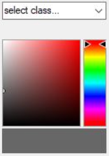

Figure 14 Class Color Assignment - Change class graphing colors

Colors of each class can be changed through the provided color spectrum on the right panel. To perform color changes, choose the desired class by clicking on the drop-down menu just above the color spectrum palette, then choose the desired color and shade with said palette. Each class and their respective color will be presented on the legend provided at the top of the right panel.

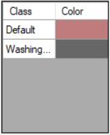

Figure 15 Legend - Provides name of class and assigned color

# Secondary Properties Window

There are three levels the user can manipulate at: classes, sets, and dimensions. A class may contain one or multiple sets and a set may contain one or multiple dimensions. In the case the user would like to see or manipulate properties of these levels, the user can do so with either the right panel of the main window, or the secondary window. The right panel does not have given access to all the functions, only functions we thought would be the most accessed by the user, due to limited space and desire to not make the UI look overwhelming to the user. Consequently, the secondary properties window will be the only option to access all property functionality.

## Class Tab

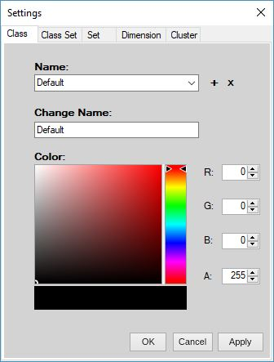

Figure 16 Class tab manages name and color fields

Classes are what contain multiple n-dimensional coordinates in the software. While the ideal number of classes is no more than five classes per read in text file, the software is capable of graphing more if necessary. By default, each class is by default labeled as “Class I, Class 2, … Class m” respectively, where ‘m’ is the number of classes. Class names can color fields can be changed in the class tab. Changes affect the class that is currently selected in the “Name:” drop-down list. When satisfied with field changes, press either “OK” or “Apply”.

## Set Tab

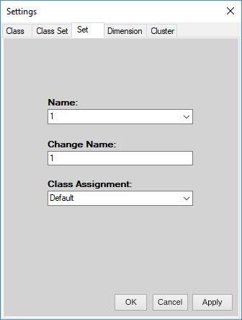

Figure 17 Set tab manages set name and class assignment

N-dimensional coordinates are considered “sets” in the software and each term is used interchangeably. Sets can consist of as many dimensions as the user desires in the properly formatted text file. Set fields that can be managed are the name, and class assignment. Each set is by default labeled as “1,2,3, … n” respectively, where ‘k’ is the number of sets. Fields that can be changed include the name of the set, and the class the set belongs to. Changes affect the set that is currently selected in the “Name:” drop-down list. When satisfied with field changes, press either “OK” or “Apply”.

## Dimension Tab

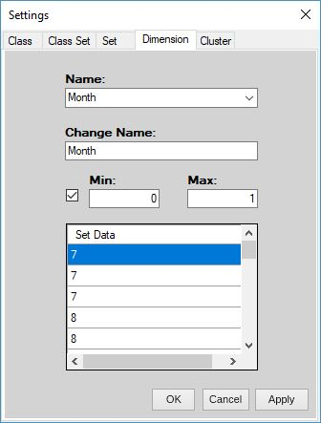

Figure 18 dimension tab manages dimension name, scaled minimum and maximum, and dimension values

Dimensions are the individual values that lie within an n-dimensional coordinate. Each dimension is by default labeled by the position they exist on the graph as “1,2,3, … n “, from left to right respectively, where ‘n’ is the number of dimensions. Dimension values are scaled with the min being 0 and the max being 1. The set data panel shows the dimension values that are read from the text file for the affiliated set. Dimensions can be moved around the screen and change position but will still retain the same number as that is the dimension’s name. Fields that can be changes include the dimension name, scaled minimum and maximum. Changes affect the dimension that is currently selected in the “Name:” drop-down list. When satisfied with field changes, press either “OK” or “Apply”.